Experiment 11: Design PDA Using Simulator to Accept the Language
Aim
To design and simulate a Push Down Automaton (PDA) that accepts the language
where the number of b's is twice the number of a's.

Algorithm
- Start from the initial state.
- Push the bottom stack symbol Z onto the stack.
- For every input a, push two stack symbols (AA) onto the stack.
- After all a's are read, move to the next state when the first b is encountered.
- For every input b, pop one A from the stack.
- Continue until all input symbols are processed.
- If the input is completely read and only the bottom stack symbol Z remains on the stack, accept the string.
- Otherwise, reject the string.

Procedure
- Open the PDA simulator (JFLAP or any PDA simulator).
- Create the required states.
- Mark the initial state as the start state.
- Push the initial stack symbol Z.
- Add transitions to push AA onto the stack for every input a.
- Add transitions to pop one A for every input b.
- Add an accepting state that is reached when the stack contains only Z after the input is completely read.
- Run the simulator with different input strings and verify the results.

Input
abb
aabbbb
aaabbbbbb

Output
Input : abb → Accepted
Input : aabbbb → Accepted
Input : aaabbbbbb → Accepted
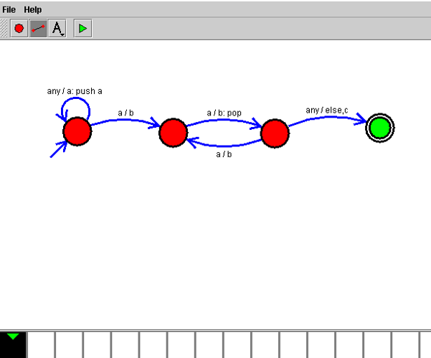

Result
Thus, the Push Down Automaton (PDA) was successfully designed and simulated to accept the language L = { aⁿb²ⁿ | n ≥ 1 }. The PDA correctly accepted strings in which the number of b's is exactly twice the number of a's.

